# Game Two – Mountain Of The Martyr – Outline

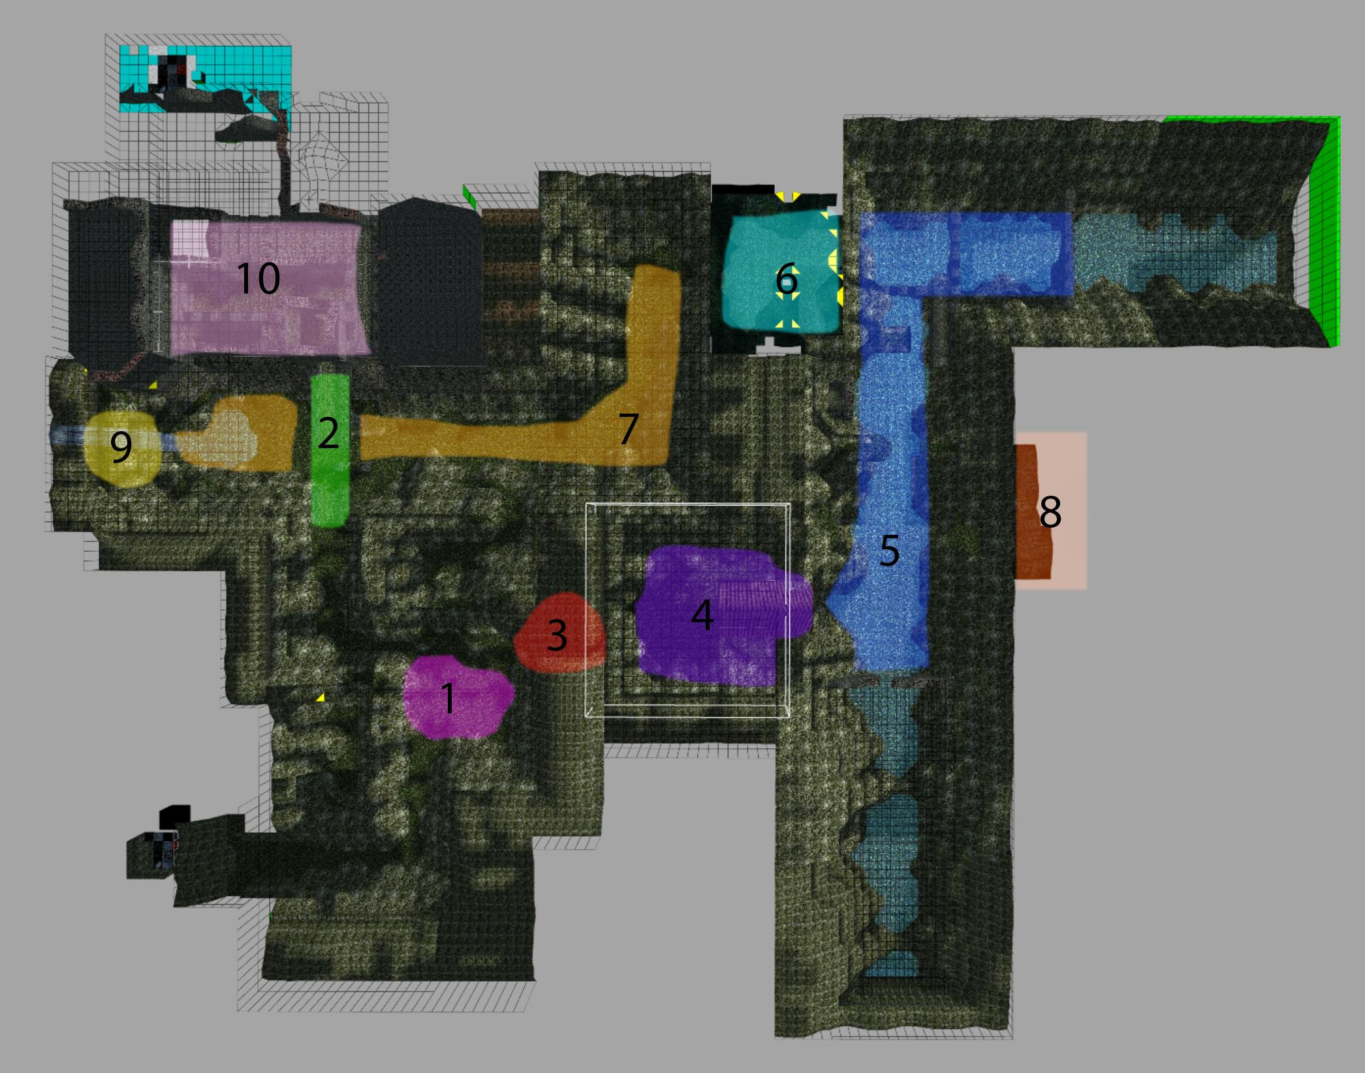

## In short:

* The level takes place in the Bavarian Alps, along the German-Austrian border. It is a mountainous region, and the action is set within a network of hills, valleys and rivers - as well as the ruins of a long-abandoned medieval settlement. The atmosphere is a mix between greyish style of *The Witcher* and the lush natural environments featured in *The Elder Scrolls: Skyrim*.
* The level is intended to introduce the game’s mechanics, and the cinematic nature of *The Dark Renaissance* as a whole. It is the easiest among the game’s levels, and the most “pleasant” visually and otherwise. In other words, the Mountain of the Martyr serves as a transition between the lighter tone of classic TR games, and the darker themes of AOD and moreso TDR itself.
* Lara’s goal for this level is to find a way to get inside Castle Kriegler. The castle itself can be seen from the clearing with The Dead Tree that Lara starts out in, but is located on the other side of a grand bridge that has long since crumbled, meaning Lara will have to find her way inside by another means as she explores the surrounding areas.

## Key areas:

1. **The Dead Tree** - this is the first location Lara visits. It is a small clearing among the woods, with a dead tree for a centerpiece. This tree has fallen over, and is so tall that its branches can only be reached from one of the hillsides, which is too steep for Lara to climb. She will need to reach these branches, however, in order to retrieve a *stick* that she will combine with other items to craft a *torch*.
2. **The Bridge** – Castle Kriegler can only be reached via this bridge, which has gone to ruin over the years. The parts of the bridge that are still standing are set too far apart to be jumped across, and so Lara will need to find some other way to cross it. Looking down to where the river flows, she can see a **Watermill**, which she will have to reach, in order redirect water into a connecting water tower, enabling Lara to swim to its top, whereby she will be able to access the **Castle Entrance** by climbing the ruined battlements she can reach from there.
3. **The Cave** - this cave connects the **Dead Tree** area with the **Chapel**. Inside, there’s a small cairn - perhaps the resting place of an accomplice to the Cabal - where a key has been buried. This key will later grant Lara access to the **Castle Valley** from inside the **Cavern**, a larger (and partly underground) cave that the Cabal have fortified. Inside the cave, there’s also an opening leading upward and to the side, which will bring Lara to the crest of the hillside from which she can reach the **Dead Tree**’s branches. It is very high up and blocked-off by debris, however, and so Lara will need to stack objects as part of a small pushable puzzle in order to reach it.
4. **The Chapel** – this seemingly abandoned XVIth-century structure houses an underground mausoleum, the entrance to which is unlocked upon lighting two lanterns inside - for which Lara will need the *torch* - and turning them so as to illuminate the polychrome that decorates the chapel’s interior walls. Outside, in the surrounding graveyard, manipulating the tombstones belonging to the workers who built the chapel, based on a riddle found inside, will grant Lara access to a stash of wilderness survival supplies, including *strips of* *cloth*, needed to craft the *torch* alongside the *stick*. Inside the semi-flooded mausoleum itself, Lara will find a weak wall that she can kick apart, granting her access to the lower, waterlogged levels of the **River Valley**.
5. **The River Valley** – this location is focused on platforming challenges, and serves as an introduction to Krystian’s freeform climbing system, with loose earth forcing Lara to stay on the move as she traverses the area. She will eventually be able to reach a fortification set into the side of the valley, where the broken mechanism for a dam is located.
6. **The Cavern** is basically a connection between the River Valley and the Castle Valley.
7. **The Castle Valley** is the main valley that connects both ends of the level. On its side there are ruins of the Castle Kriegler, that Lara will have to access. This area will consist of platforming sequences and small caves, where Lara finds necessary equipment to get to the castle.
8. **The Dam Puzzle** - this is where the machinery to control the dam is. Lara will have to fix it in order to move forward.
9. **Watermill** - this will be a huge tower with the device that when working, will fill the tower with water. Once it is filled Lara will be able to swim to the higher level and access the castle.
10. **The Castle Entrance** - the main goal of the level. Once Lara enters the gate to the castle the proper Castle Kriegler level will load.

## Main puzzles:

* **The Lanterns** – this puzzle will become available once the Chapel itself is opened. Lara will have to light up two lanterns, then rotate them so all the people on the walls’ polychrome are illuminated by light. Once this is done the door to the dungeons opens where the switch to raise the grate is.
* **The Torch** - the first puzzle that Lara has to solve involves creating a torch to light up lanterns or burn bushes that block the way. For that she will need three things:
  + **Stick** - which she will break off of a dead tree in the first location.
  + **Cloth** - maybe she will find an old flag and use it for this purpose?
  + **Fire** - Lara will find an old camp in The Castle Valley, with an extinguished bonfire. Using a **lighter** she will ignite the bonfire, from which she will then light up the torch.
* **The Dam** - this puzzle will be placed in the River Valley section of the level. Lara will have to close the dam so she can get access to the Cave.
* **The Waterfall** - A grate is visible behind a
* **OBSOLETE:The waterfall** - A waterfall of deadly water is blocking the way to the iron grate behind which is the second entrance to the castle. Once the waterfall is gone Lara will have to enter **the Chapel** and light up lanterns in order to raise the grate.

## Gameplay flow:

1. Lara starts on a path that is blocked by a wired fence on one side. She goes along the path and enters **the Dead Tree** area. A **shadow of a wolf** appears (+howling sound). Lara follows the shadow to **the Bridge** area.
2. Lara walks towards the bridge. The **CUTSCENE** appears where the bridge collapses. Lara has to run back to safety. Another **wolf shadow** appears, going back to **the Dead Tree** area.
3. Lara follows the shadow. She sees it again, this time hiding behind bushes. There is a **new path** opened that wasn’t available before. She enters a cave, where **wolves attack her.** She kills them all and then finds a decaying body of a man (a WWII soldier? A guard? A lost Lux Veritatis member? TBD).
4. **From this point the level becomes less linear. There are two possible ways to go.** She can either pass the **Wolves Cave** and enter the **Chapel** area OR she can return to the **Bridge** area and open the door to the **Castle Valley.**
5. **If player goes to the Castle Valley** he will see a grate behind the waterfall. The grate is down and the waterfall is blocking the way. If Lara touches the water, she dies.
6. **Objectives: She has to stop the water and raise the grate, but how?**
7. **To stop the water** Lara will have to